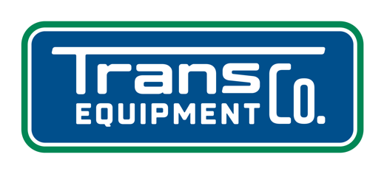

- 4423 Oregon Pike, Ephrata, PA 17522 - (717) 859-2095 - www.transequipmentinc.com -

New 2027 HAHNZ Dump Trailer

Body: 40’ x 102” Frameless
Smooth Aluminum Polished Sides
72” Side Height
Heavy Floor Last 10’
8-5-285” Hoist
Man Door
(2) Rows of (9) Lights Each Side
Tailgate: Two Way Gate Hinged Driver’s Side
Smooth Panels
Rubber Seal
(4) Hand Tighteners
21” Grain Chute
Chassis: Aluminum Draft Arms
(2) Pair of Aluminum Fenders
Flaps Behind Front Axle
Jost Aluminum Landing Gear
10’2” Hendrickson Air-Ride Spread
Lift on Front Axle
Drum Brakes
11R22.5 Tires (8) Aluminum Wheels
(2) Crossfire Back Up Lights
(6) S/T/T Lights Across the Rear
Tarp: Shur-Co Manual Loc-N Roll tarp System with Aluminum Caps
Weight: 12,720 lbs.
GVWR: 80,000 lbs.

